S. Rushi Keshava Reddy
192472355
CSA-0606- DESIGN AND ANALYSIS OF ALGORITHMS
CHAPTER 1 - LIST OF EXPERIMENTS
- SELECTION SORT

Question 1: Trophy Ranking System (Selection Sort)
Objective
Implement Selection Sort to arrange players' scores in descending order.
Problem Statement
A sports event organizer has recorded the scores of 50 participants but needs to display only the top 5 scorers on the leaderboard screen. Since only a few top values are needed, the organizer decides to use Selection Sort to arrange the scores.
CODE:
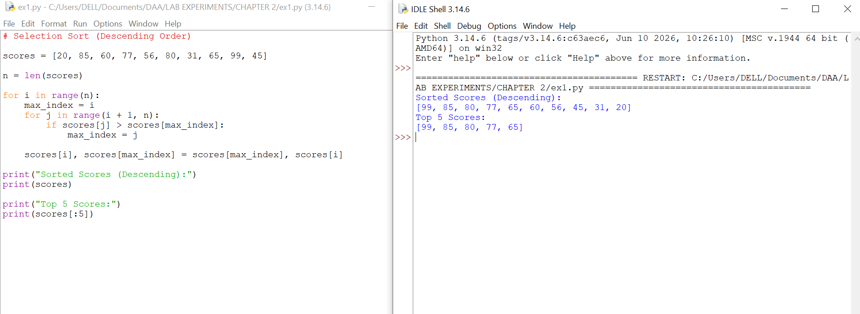
Explanation
- Selection Sort repeatedly finds the largest element from the unsorted part.
- It swaps that element with the current position.
- After sorting, the first five elements are the top 5 scores.

Question 2: Memory-Constrained Embedded Device
Objective
To sort temperature readings using Selection Sort with minimum swaps.
Problem Statement
A low-memory IoT device stores temperature readings. Since memory writes are costly, use Selection Sort because it performs at most n − 1 swaps. Count the swaps to prove it. (Based on the uploaded lab sheet.)
Approach
- Find the minimum element.
- Swap only if needed.
- Count the number of swaps.
CODE:
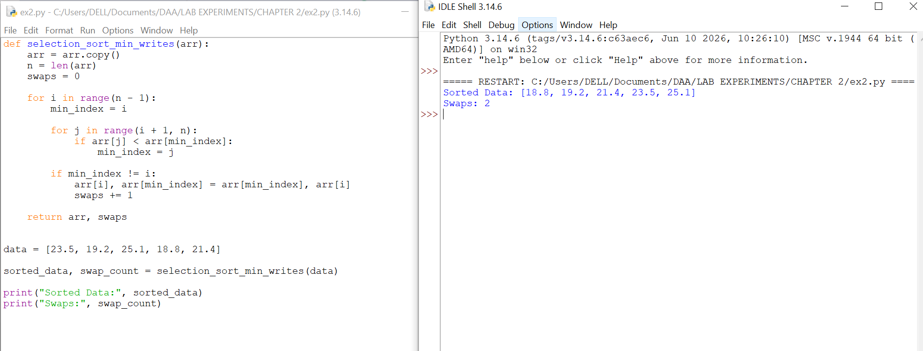

Complexity Analysis
Aspect | Complexity
Time | O(n²)
Space | O(1)
Swaps | ≤ n − 1

Question 3: Library Book Reordering
Objective
To arrange book IDs using Selection Sort and count the number of physical moves (swaps).
Problem Statement
A librarian wants to arrange books by ID number. Moving books takes time, so use Selection Sort and count the number of swaps (physical moves).
Approach
- Store book IDs in a list.
- Use Selection Sort.
- Count swaps only when two books are exchanged.
CODE:
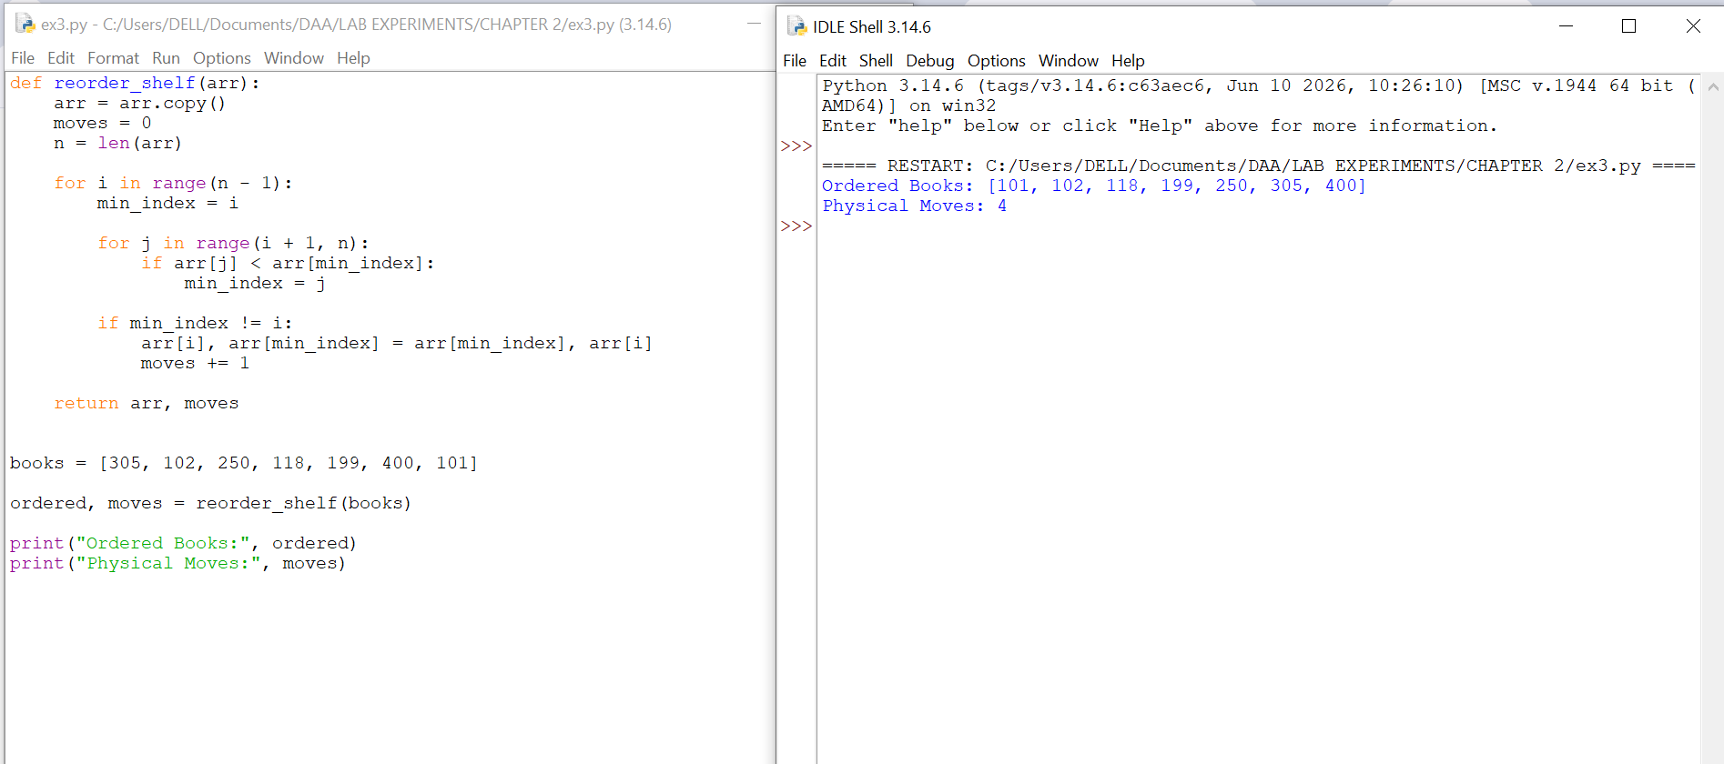
Complexity Analysis
Aspect | Complexity
Time | O(n²)
Space | O(1)
Physical Moves | ≤ n − 1

Question 4: Contest Prize Distribution
Objective
To rank participants in descending order of scores using Selection Sort.
Problem Statement
In a coding contest, rank participants by their scores. Print the participant names in descending order without using any sorting library.
Approach
- Store participant names and scores.
- Use Selection Sort in descending order.
- Print the ranked participants.
CODE:
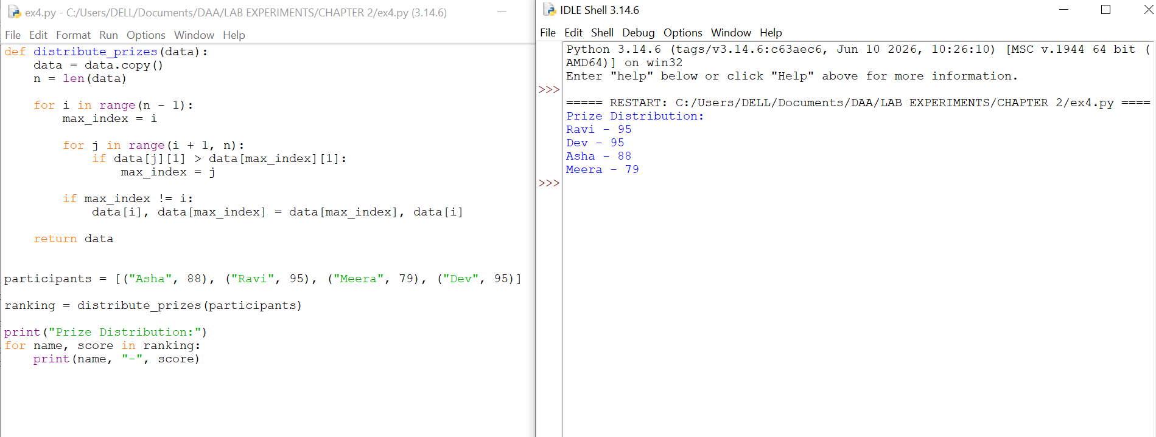

Complexity Analysis
Aspect | Complexity
Time | O(n²)
Space | O(1)

Question 5: Small Dataset in a Mobile App
Objective
To sort a small list of item prices using Selection Sort.
Problem Statement
A shopping app needs to sort a small list of recently viewed item prices. Use Selection Sort and show that it works efficiently for a small dataset.
Approach
- Store item prices in a list.
- Use Selection Sort to arrange them in ascending order.
- Display the sorted list.
CODE:
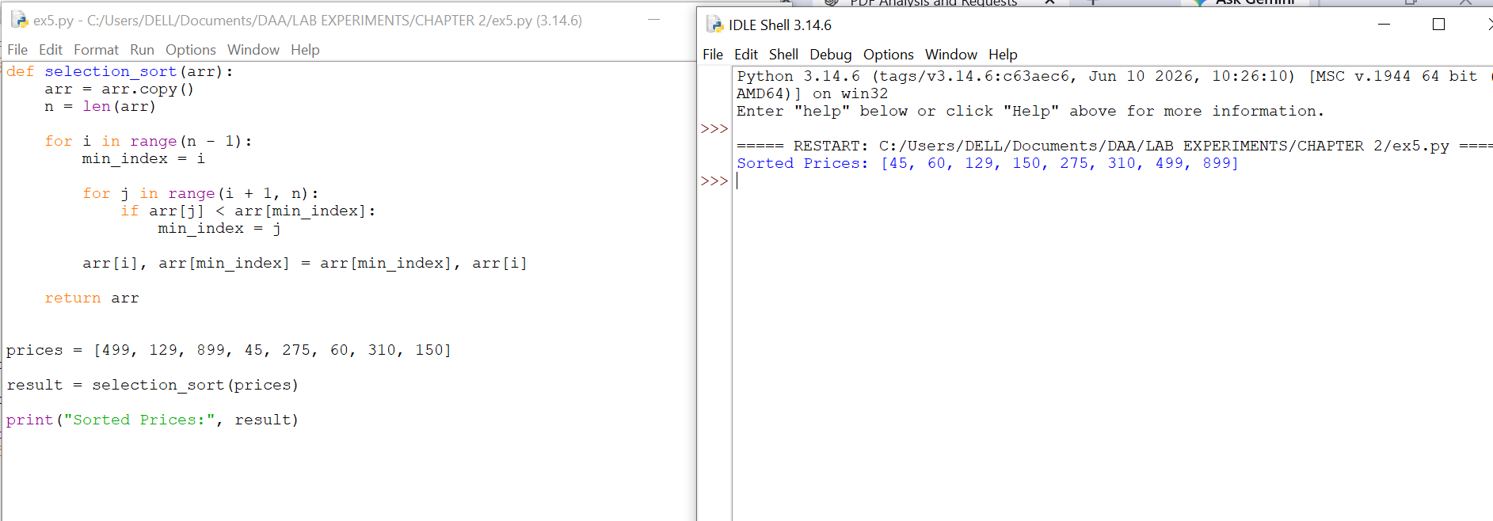
Complexity Analysis
Aspect | Complexity
Time | O(n²)
Space | O(1)

Bubble Sort
Question 1: Exam Result Slip Correction
Objective
To sort student roll numbers using Optimized Bubble Sort with an early-exit flag.
Problem Statement
A teacher has a nearly sorted list of student roll numbers. Use Optimized Bubble Sort to arrange them in ascending order and stop early if the list is already sorted.
Approach
- Compare adjacent elements.
- Swap if they are in the wrong order.
- Use a swapped flag.
- If no swaps occur in a pass, stop the algorithm.
CODE:
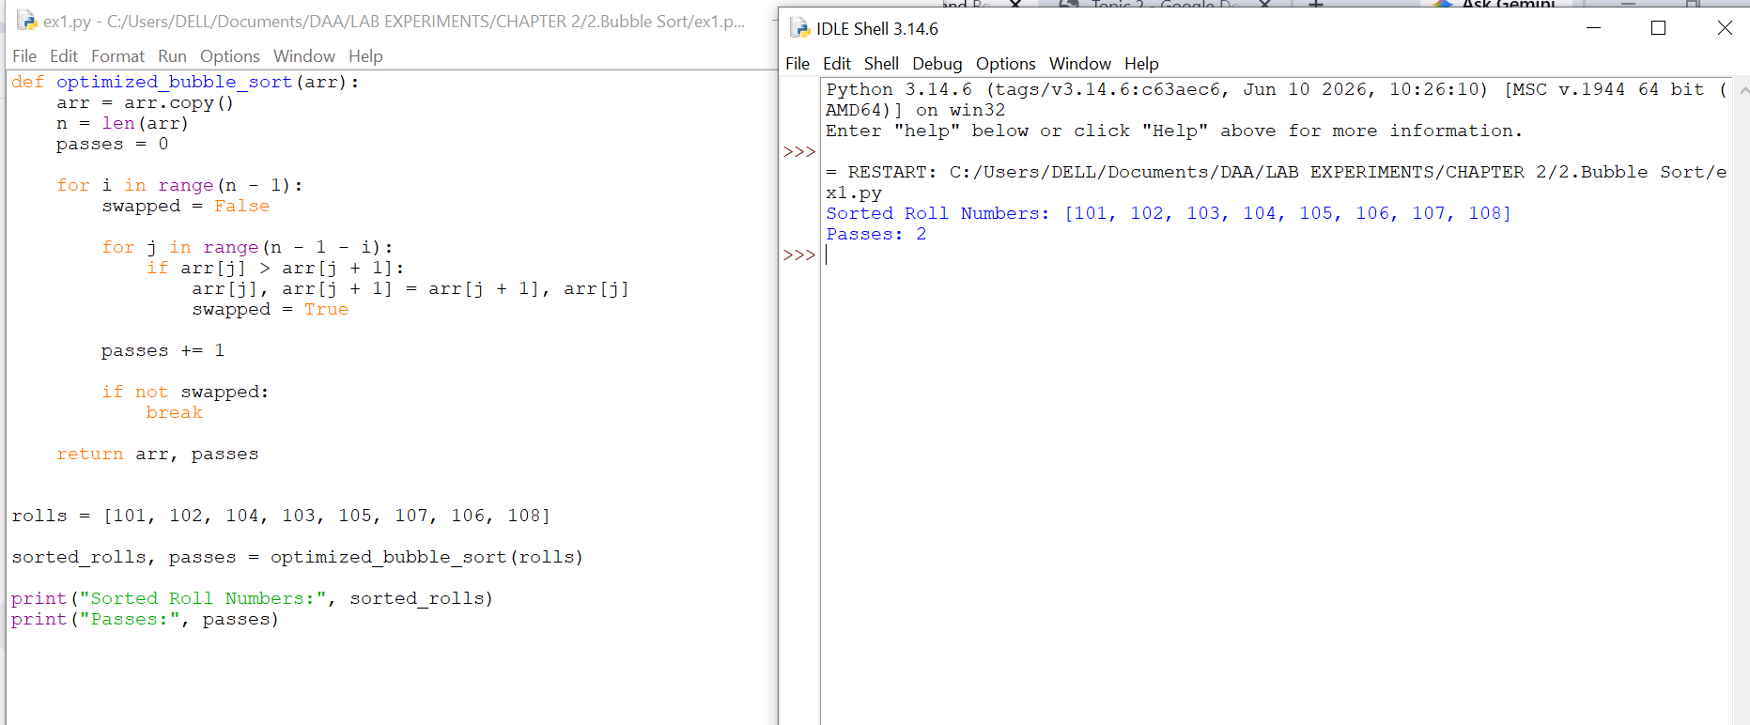

Question 2: Traffic Signal Priority Queue

Objective
To arrange vehicles based on priority using Bubble Sort.
Problem Statement
At a traffic signal, vehicles have different priorities (ambulance > bus > car). Use Bubble Sort to arrange the queue whenever a new vehicle arrives.
Approach
- Assign a priority to each vehicle.
- Use Bubble Sort to arrange vehicles in descending priority.
- Display the sorted queue.

CODE:
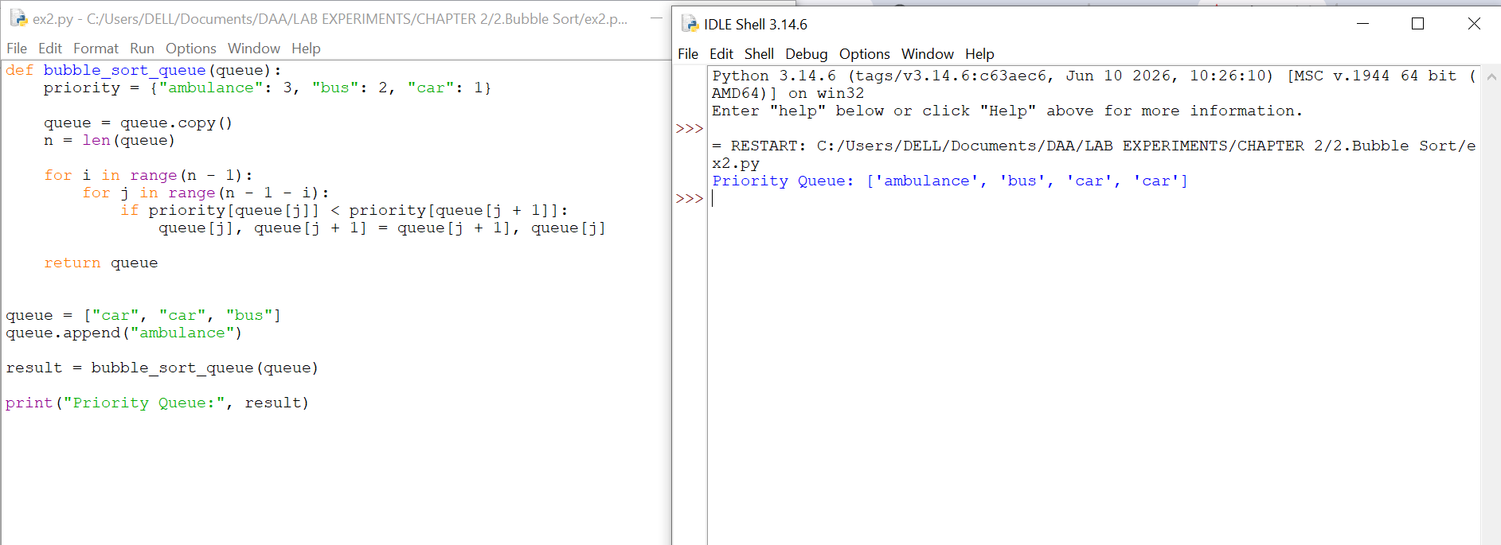

Question 3: Bubble Sort Visualization Tool

Objective
To show the array after each pass using Bubble Sort.
Problem Statement
Build a Bubble Sort program that stores the array after every pass. This helps visualize how the largest elements move to the end.
Approach
- Apply Bubble Sort.
- Store the array after each pass.
- Print all the stored arrays.

CODE:
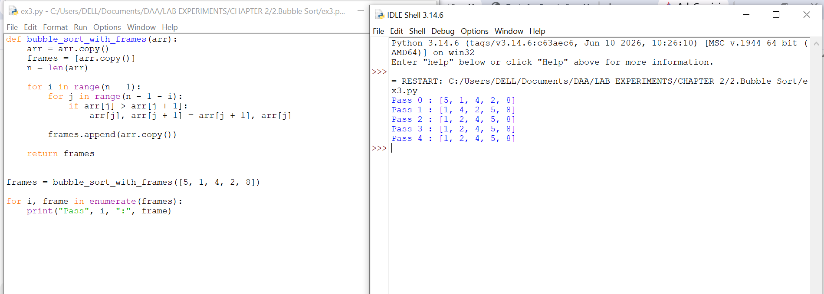

Question 4: Sorting Sensor Alerts by Severity

Objective
To sort sensor alerts using Bubble Sort and compare the plain and optimized versions.
Problem Statement
A monitoring system receives sensor alerts that must be sorted by severity. Implement both Plain Bubble Sort and Optimized Bubble Sort and compare their performance.
Approach
- Sort the alerts using Plain Bubble Sort.
- Sort the same alerts using Optimized Bubble Sort.
- Compare the number of comparisons.
CODE:
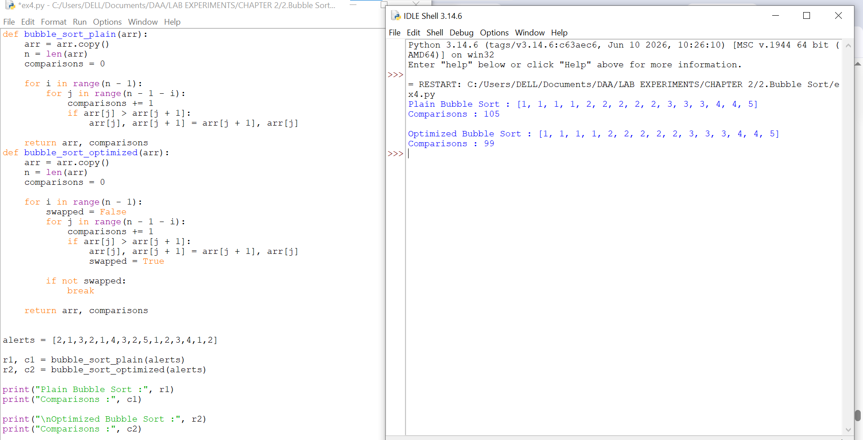

Question 5: Card Game Hand Sorting

Objective
To sort a player's cards using Optimized Bubble Sort.
Problem Statement
A card game app needs to sort a player's hand whenever a new card is added. Use Optimized Bubble Sort and count the number of passes required.
Approach
- Add the new card to the hand.
- Use Optimized Bubble Sort.
- Count the number of passes taken to sort the cards.

CODE:
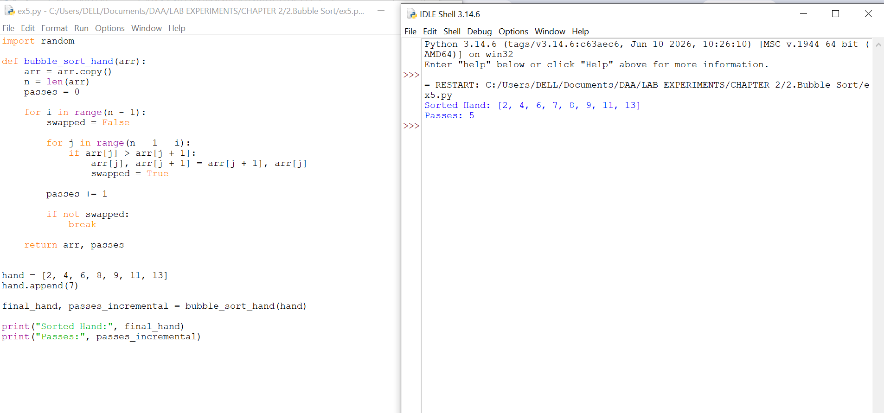

Insertion Sort:

Question 1: Live Leaderboard Updates
Objective
To update a leaderboard using Insertion Sort.
Problem Statement
An online game updates a player's score. Use Insertion Sort to insert the updated score into the correct position without sorting the entire leaderboard.
Approach
- Add the updated score.
- Use Insertion Sort to place it in the correct position.
- Count the number of shifts.
CODE:
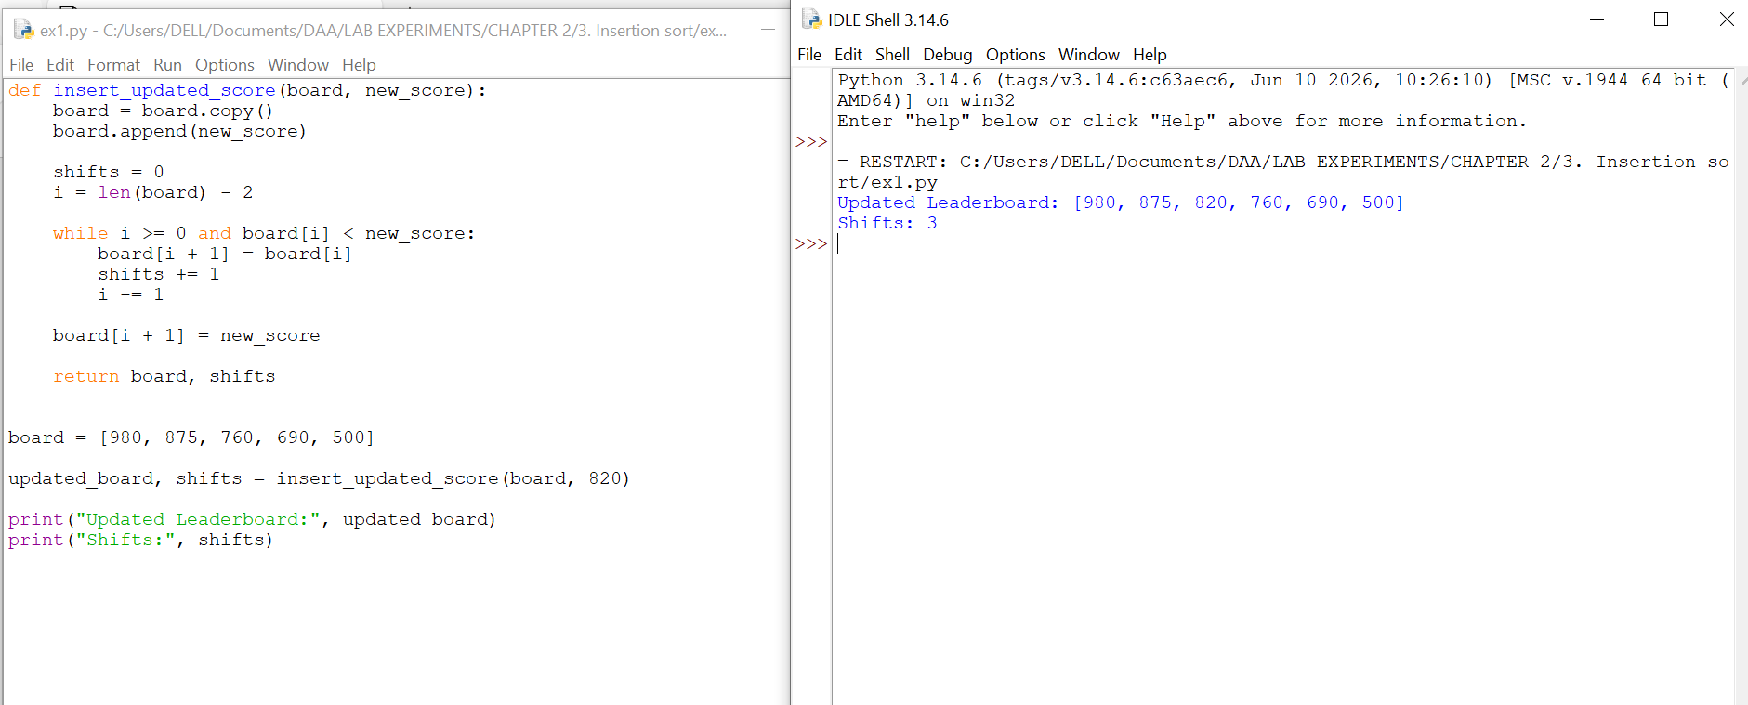
Complexity Analysis
Aspect | Complexity
Time | O(n)
Space | O(1)

Question 2: Card Sorting While Playing

Objective
To sort cards using Insertion Sort as they are picked one by one.
Problem Statement
A player picks up cards one at a time. Insert each new card into the correct position using Insertion Sort.
Approach
- Start with an empty hand.
- Insert each new card into its correct position.
- Keep the hand sorted after every insertion.
CODE:
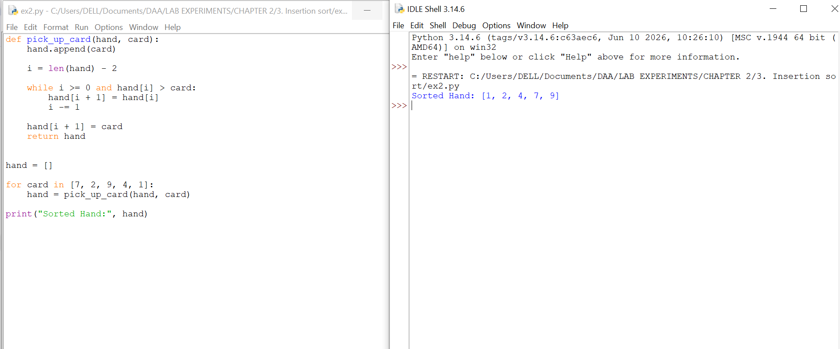

Complexity Analysis
Aspect | Complexity
Time | O(n) per card, O(n²) total
Space | O(1)

Question 3: Real-Time Stock Price Feed

Objective
To insert stock prices into a sorted list using Insertion Sort.
Problem Statement
A trading system receives stock prices one at a time. Use Insertion Sort to insert each new price into the correct position while keeping the list sorted.
Approach
- Start with an empty list.
- Insert each new price into its correct position.
- Keep the list sorted after every insertion.
CODE:
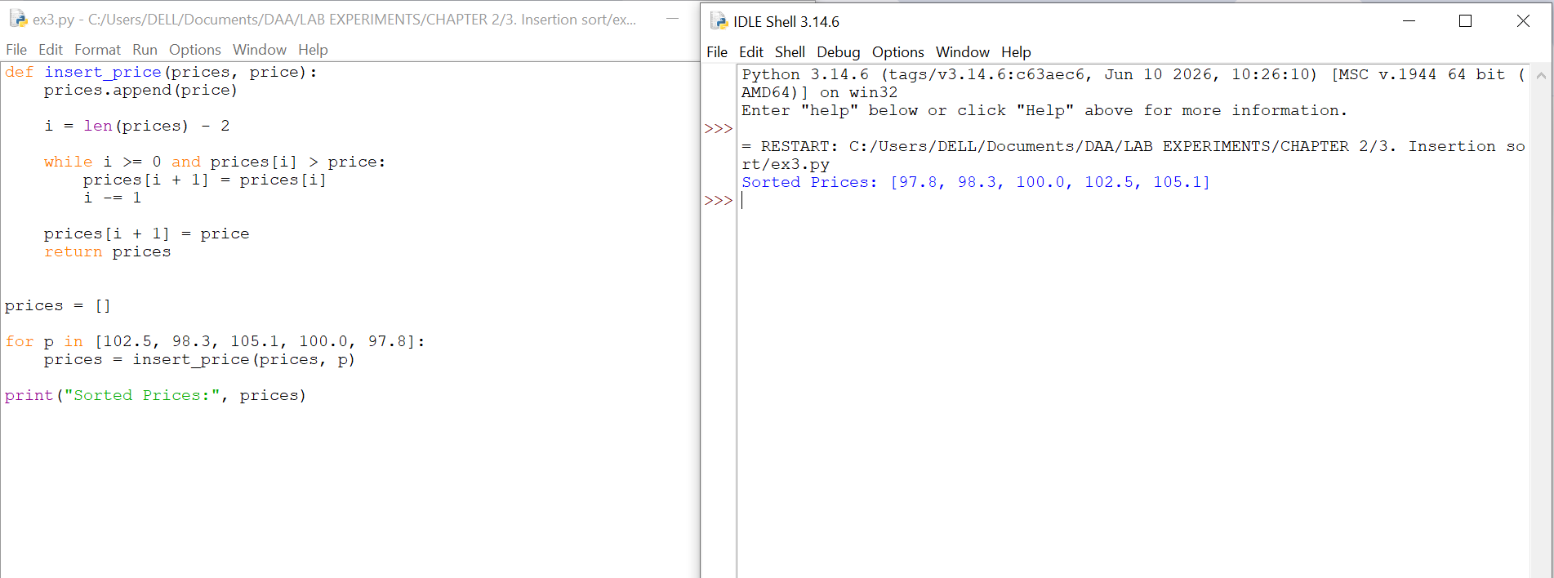

Complexity Analysis
Aspect | Complexity
Time | O(n) per insertion, O(n²) total
Space | O(1)

Question 4: Playlist Reordering by Recently Added

Objective
To insert a new song into a sorted playlist using Insertion Sort.
Problem Statement
A music app adds a new song to an already sorted playlist. Use Insertion Sort to place the new song in the correct position.
Approach
- Add the new song to the playlist.
- Shift longer-duration songs to the right.
- Insert the new song in the correct position.
CODE:
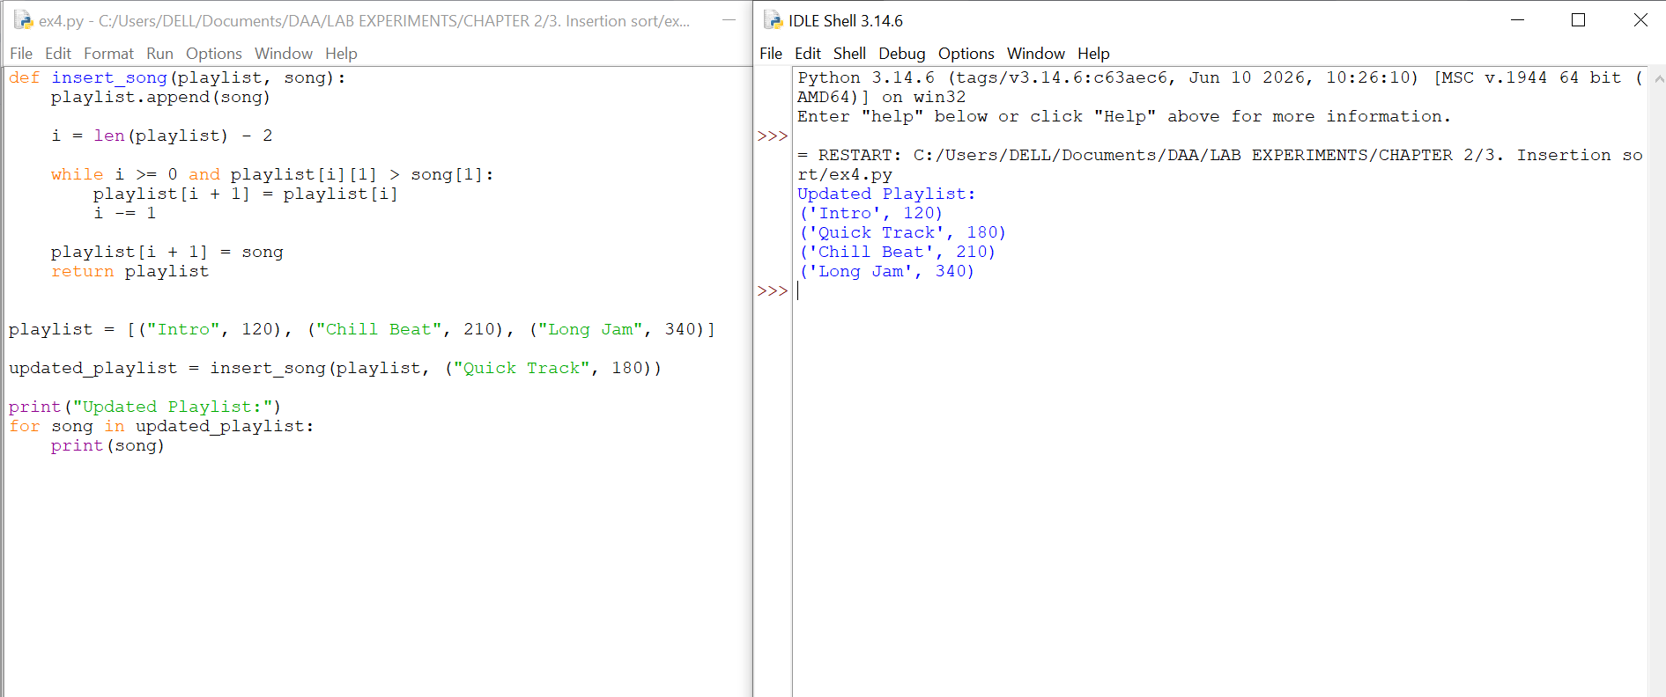

Complexity Analysis
Aspect | Complexity
Time | O(n)
Space | O(1)

Question 5: Nearly Sorted Sensor Log Correction

Objective
To sort a nearly sorted sensor log using Insertion Sort and count the number of shifts.
Problem Statement
A weather station records temperature readings that are almost sorted. Use Insertion Sort to arrange the readings and count the number of shifts.
Approach
- Use Insertion Sort on the sensor log.
- Count the number of shifts.
- Display the sorted log and total shifts.
CODE:
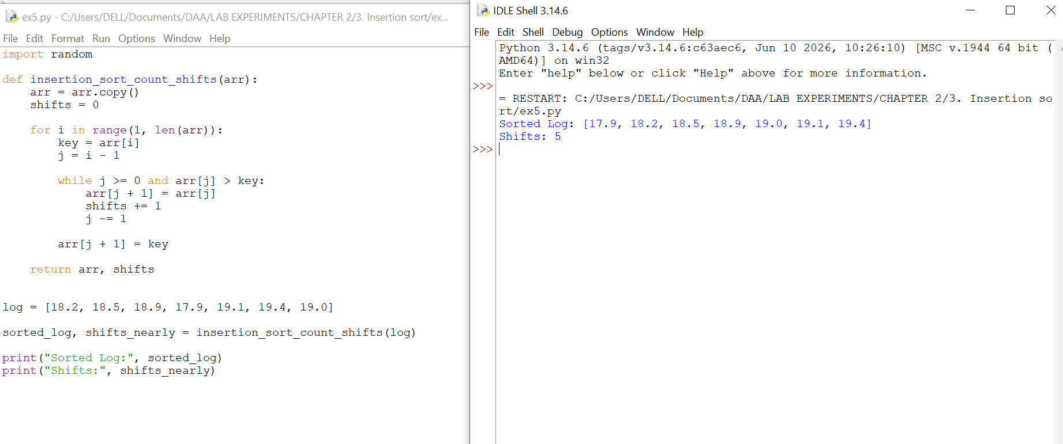

Complexity Analysis
Aspect | Complexity
Nearly Sorted Data | O(n)
Randomly Shuffled Data | O(n²)

